Our themes for the next term are ‘All About Me’, ‘Autumn’ and ‘Christmas’. Here are some of the activities we will be exploring in Preschool.
Please support my learning by also helping me at home.
We will discuss our families and where we live.
Please can you email or send in a photograph of who lives in your house. These will also be displayed in Preschool.
We will be exploring the story ‘The Colour Monster’ and talking about our feelings.
The children will be talking about their features and what they look like.
We will discuss differences and similarities to each other. We will explore different resources with the children helping them to make self-portraits.

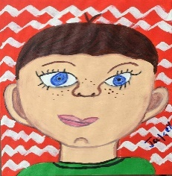
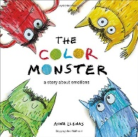



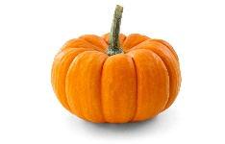



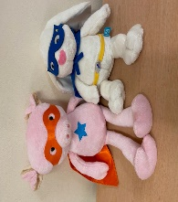
Our Christmas activities will include writing letters to Father Christmas, wrapping presents, making calendars, cards and decorations.
The children’s Christmas Party will be held on Monday 15th December 1.15-3.15pm.

will be held on
We will be sharing books and stories about recycling and looking after our environment.
The children will use recycling bins in Preschool and take our snack waste to compost at the allotment.
We will be learning about and celebrating the festivals
Halloween, Bonfire Night, Diwali, St Andrews Day and Christmas.
If there is anything else your family will be celebrating, please let us know.
We will be learning our Christmas Performance songs. The children will perform these in our Nativity Performance on the 16th December.
We will be learning the Preschool routine & how to tidy up & look after our toys.
We will be looking at the change in season. We will go on Autumn walks to observe changes and collect leaves, conkers etc. The children will experiment with Autumn coloured paint and use natural resources for counting.
We would love it if you could share with us anything you discover when out for a walk.

The older children will visit our allotment and help to plant and keep it tidy.
The children will pick our produce to use in cooking and tasting activities.

We will be discussing our Golden Rules and using ‘Bounce the Brilliant Bunny’ and ‘Porky the Perfect Pig’ our superhero mascots to help support this. (Please see attached letter)

