Our themes for the next term are ‘Winter’, ‘Hibernation’ and ‘Spring and Growing’ Here are some of the activities we will be exploring in Preschool.
Please support my learning by also helping me at home.
We will be talking about what hibernation means and which animals hibernate.
We will share stories about bears and make dens.
We will be exploring the story “ Going on a Bear Hunt”.
Can we act the story out and predict what is going to happen next?

We will be looking at the change in season. We will go on Winter walks to observe changes.
The children will play with ice, what causes water to freeze and why does it melt?
We will experiment with cold coloured paint and resources in our art and craft activities.
Please ensure your child has suitable clothing for exploring outside, especially if we get snow!!




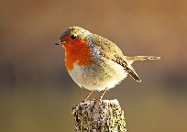



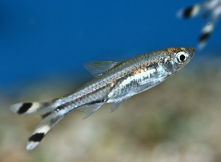
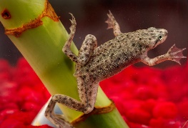
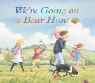


As Spring approaches, we will observe and explore the changes in our enviroment.
We will continue to encourage the independence skills and self care-skills of the children who start school this year. Please can parents support dressing skills, recognising and beginning to write names & independent toileting at home.

We will be learning about and celebrating the festivals
Chinese New Year, Pancake Day, Valentines Day, Ramadan, Mothers Day and St. Patricks Day
If there is anything else your family will be celebrating, please let us know.
We will be inviting our Mummy’s in for Mother’s Day on Monday 31st March at 2pm to join in with a craft activity and cake. This will be followed by our annual Easter Egg hunt before going home.
The older children will visit our allotment and help to plant and keep it tidy.
Any plant donations would be greatly received.
We have some new additions to our tropical fish tank which the children continue to enjoy.
We have had 3 frogs, 2 catfish and 5 scissor fish.

We will also learn how to care for the birds and other creatures during the winter.
We will make bird feeders to hang in the garden, counting and naming the birds we see.

