Our themes for this term are “Lifecycles and Minibeasts, People who Help us, Keeping Healthy, Oral Hygiene and Under the Sea.” Here are some of the activities we will be exploring in Preschool.
Please support my learning by also helping me at home.
The children will be doing lots activities and discussing the roles of people who help us including the fire service, police, doctors/nurses, vets, farmers. Any Parents who would like to come in and talk about their jobs with the children would be very welcome.

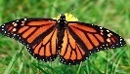
We will be exploring the story “The Very Hungry Caterpillar.”
Can we count out the fruit and predict what is going to happen next in the story?

We will be learning about lifecycles and watching real caterpillars grow big and fat and build their cocoons. When they emerge as butterflies, we will care for them and then release them.
We will also have some ladybird larvae which we will watch grow into fully grown ladybirds in their very own
“bugland” before being released into the garden.

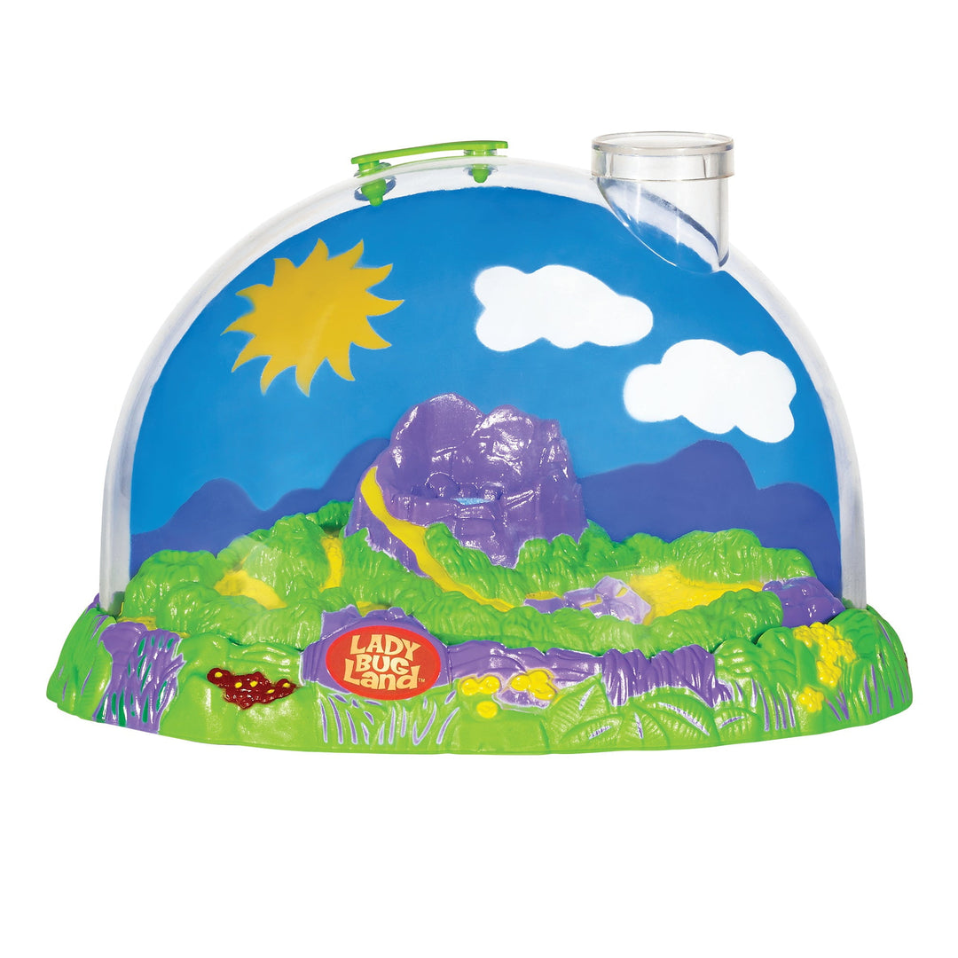








The photographer will be coming in to Preschool on Monday 16th June at 9.30am. She will be taking individual photographs of all children and a group photo of the children who will be leaving. More details to follow.
take a group Preschool photograph

We will be closed on Friday 20th June due to a Teacher Training Day at the school.
We will start to prepare the children for their transition to “big” school.
Our leavers will also be starting a library scheme for the last few weeks of term and we will begin some small group times to look at phonetic sounds in simple words.

Our Last day at Preschool will be Tues 22nd July, returning on wed 3rd Sept.
Have a lovely summer everyone!!
Our leavers celebration day will be held on Thursday 17th July.
Please note this a change to the original date.
It will include a fun filled morning with a special treat, followed by a party afternoon. Parents of leavers are invited in for a presentation at 2.30pm.
More details to follow.

Under the Sea will be the last theme before we break up for the Summer. We will be learning about some of the creatures that live in the sea.
We would love it if you are on holiday over the next few weeks if you could collect us some shells and seaweed to use in our activities.

We will be inviting our Daddy’s in for Father’s Day on Monday 16th June at 2.15pm to join in with a craft activity and cake. More details to follow.
The children will be practising for Sports day which will be held on Monday 30th June at 2pm on the playing field next to Preschool. Mums, dads and grandparents are all welcome to come and watch and cheer the children on!!
We will be learning how we keep our bodies healthy by exercising, eating healthily and sleeping lots! This will also include oral hygiene and discussing visiting the dentist.



